Slippery Rock University Russell Wright Alumni House and Conference Center
105 Campus Dr., Slippery Rock, PA 16057 - (724) 738-4153 - www.rockalumni.com

Reservation Request Form
The Alumni House is available for meetings, seminars, lectures, themed parties, team building, conventions, luncheons, tea parties, indoor tail gate parties, tradeshows, family celebrations, bar and bat mitzvahs, corporate events, awards banquets, holiday parties, fundraisers, press conferences, rehearsal dinners, wedding ceremonies and receptions and black tie gala events.
Cost*: $250 per day
*A 10% discount rate off facility rental fees will be given to any current member of the SRU Alumni Association for any event they schedule. Membership will be verified at time of reservation.
*The Alumni House is available for use, free of charge, to SRU On-Campus Groups consisting of 50% or more SRU students, staff, and/or faculty. Reservation fees are only waived when above is confirmed in writing by the Office of Alumni Engagement.
Contact Person:
Contact Phone:
Contact Email:
Billing Address (off campus only):
Organization & Department (on campus only):
Cost Center Number for Facilities Work Order (on campus only):
Briefly Describe the Event, Including Event Name:
Number of Individuals Attending:
Start Time: End Time:

Date: Click here to enter a date.

Do you need your event added to the University Calendar? Choose an item.
Catering at the Event? Choose an item.
(Contact Catering Department for all food, beverages and table linens at 724-738-2832.)
Alcohol at the Event: In order to have alcohol at your event, you must have it catered by the on-campus caterer as per the current SRU alcohol policy.

Room Selection, Please Specify Room Choice: Choose an item.
Room | Dimensions | Theater Style | Banquet Style | Conference Style
Whole Conference Space | 85' x 31' | 200 | 150 | 50
Watson Room | 49' x 31' | 100 | 80 | 25
Furrie Room, includes adjacent alcove with couches/chairs | 36' x 42' | 75 | 50 | 25
Memorabilia Meeting Room | 17' x 15' | NA | NA | 8
Patio (outdoor meeting space) | 30' x 24' | NA | 16 | NA

Please Specify Style Choice, Place X by preferred style:
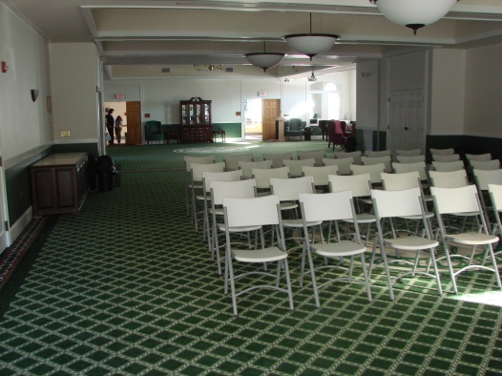
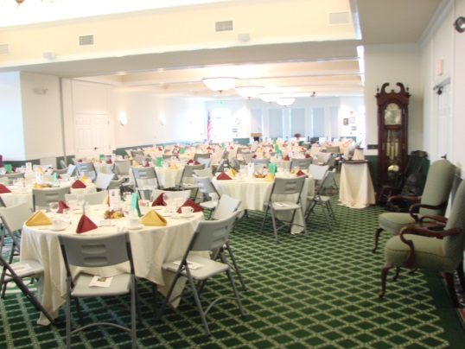
Theater Style: ☐ Banquet Style: ☐

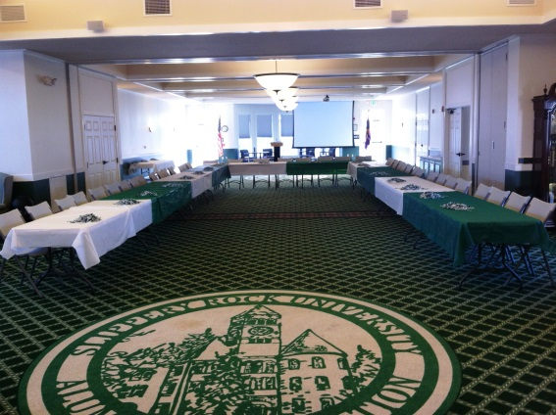
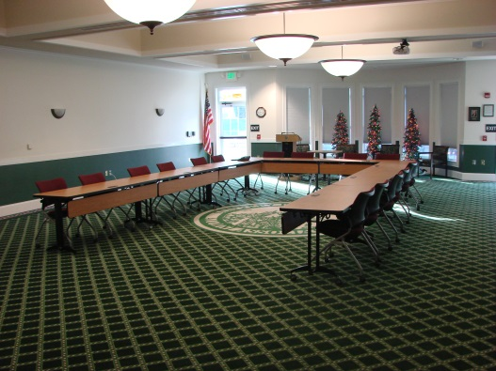
Conference Style: ☐ Conference Wooden Tables (25 Max) ☐

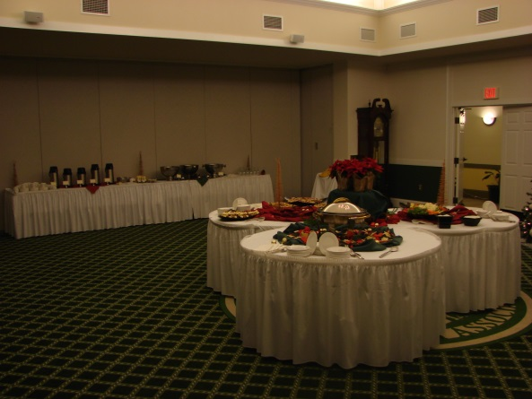
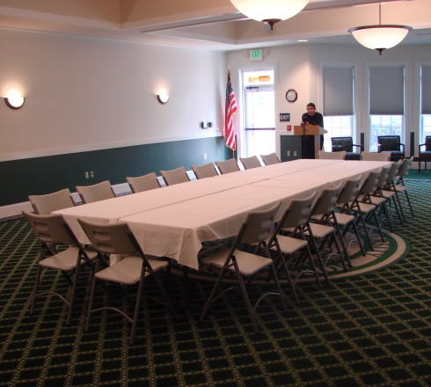
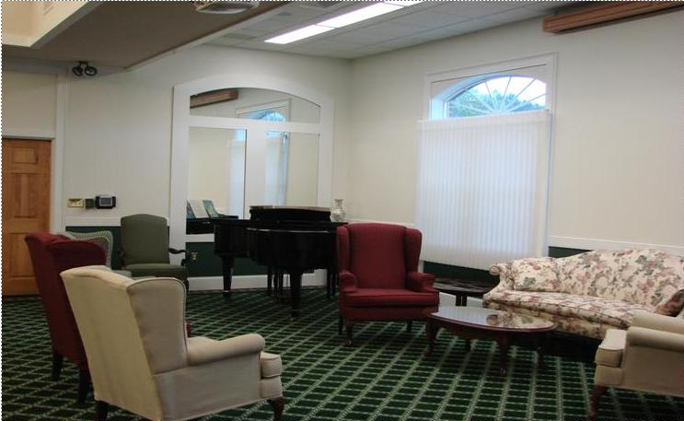
Closed Conference Style: ☐ Standing Reception Style ☐ Couch Seating Area: ☐
Technology:
Alumni Engagement DOES NOT provide a laptop or any source of tech support. It is your responsibility to bring a laptop. It is recommended a technology test visit is scheduled at least one day prior to ensure all equipment is compatible and working properly. Please X all technology that will be requested.

Projector & Screen: ☐

Microphone: ☐

Podium: ☐

Please note any questions, special requests or concerns that may need to be addressed:

Rules, Polices and Disclaimers
- Alcohol
Alcohol is only authorized if in compliance with the current alcohol policy. Only a contracted dining/food service supplier, licensed to possess and serve alcohol in the Commonwealth, may provide alcohol in association with catering services for events on campus grounds.
- Building Keys
Any events happening outside of business hours (8 a.m. – 4:30 p.m.) will require a building key. You must pick up a building key during business hours prior to event. After event ends, it is your responsibility to lock all doors and drop key in the key drop box located at the front desk before leaving. If you lose the key, you are responsible for the locksmith re-keying fee for all entry door locks. If key is not picked up before the office closes, it is not the responsibility of the Alumni Engagement to give access to the building.

- Catering & Kitchen
If the event is a catered event, all food and beverages must be supplied by the on-campus caterer (724-738-2832). There is a sink, microwave, fridge and freezer available for use upon request.

- Damages
You are responsible for all damages incurred to the Alumni House during the scheduled time of your event. This includes but is not limited to: floor stains, ceiling damages, technology damage, wall and paint damages, window and door damages, etc.

- Decorations
The use of most decorations is permitted on site. Any banners that will be hung outside of or in the facility must be approved by the Office Manager. Any banners that cannot be hung safely or without causing damage will not be approved. Balloons must be attached to weights and decorations such as flame candles, smoke machines, glitter or confetti are prohibited. All decorations are to be taken down and cleaned up directly following your event.

- External Rentals
Tables and folding chairs are provided in the rental space. If you would like different tables or chairs for your event, you must provide them at their own expense.

- Parking Permits
Alumni Engagment is not responsible for issuing parking passes to non-university guests using the facility. Parking regulations are enforced 7:30 a.m. to 5:00 p.m. Monday-Friday. During these hours, all guests are required to obtain a parking permit at the Parking Office (724-738-4785). If it is after hours, permits do not need to be obtained.

- Piano
The piano is more of a statement piece/accessory in the room and is not used very often. We have the piano tuned periodically. The temperature fluctuations in our building may have an effect on the tuning of the piano. We cannot guarantee the tuning of the piano and its use is at your own discretion.
- Set-Up and Tear Down
Set-up times will be coordinated by the Office Manager. It is your responsibility to tear down all decorations and/or event materials directly following the end of your event. You are also responsible for leaving the facility in a clean, orderly condition.

- Smoking Policy
The Alumni House is a non-smoking facility.
You have now fully completed the Russell Wright Alumni House and Conference Center reservation form and herby agree to all rules, policies, and disclaimers above. The SRU Alumni Association gifted the Alumni House to Slippery Rock University specifically for university related events. With that noted, if this request is incomplete or cannot be adequately fulfilled, Alumni Engagement has full discretion to deny reservation or rental requests. Any questions, comments or concerns may be handled and addressed by the Office Manager.

Signature: Date:

(Note: an Academic Advisor must sign and submit requests for student groups and must be present at the event.)

Please e-mail this completed form to: alumni@sru.edu

